SNR-Based Adaptive Semantic Communication

Zhentong Feng1,a (corresponding author)

1Baotou Teachers’ College，Baotou，Inner Mongolia，China

ae-mail: fzt06011996@163.com

Axida Shan2

2 Baotou Teachers’ College，Baotou，Inner Mongolia，China

-

**Abstract—Semantic communication aims to improve the efficiency of data transmission by focusing on meaning rather than exact signal reconstruction. This paper proposes an adaptive semantic communication system that dynamically adjusts the encoding strategy based on signal-to-noise ratio (SNR). Specifically, we employ a deep neural encoder-decoder pipeline for the MNIST dataset, selectively applying compression and denoising based on SNR levels. Our experiments show that adaptive transmission significantly improves classification accuracy and perceptual quality, especially under low-SNR conditions.**

**Index Terms—Semantic communication, adaptive encoding, SNR, deep learning, MNIST, CIFAR-10, PSNR, neural codec**

I. Introduction

Conventional communication systems prioritize exact bit reconstruction. Semantic communication, in contrast, aims to preserve the transmitted meaning, allowing for lossy yet meaningful reconstructions [1][2]. With the growing relevance of intelligent edge devices and noisy wireless environments, there is a pressing need for communication systems that can adapt to varying channel conditions, particularly the signal-to-noise ratio (SNR) (1).

(1)

In this paper, we explore “SNR-based adaptive semantic communication”, where an autoencoder dynamically adjusts its behavior based on the prevailing SNR conditions. For high-SNR scenarios, direct transmission with minimal processing is sufficient to preserve semantic integrity. In contrast, under low-SNR conditions, more sophisticated processing is necessary—deep learning-based encoding, compression, and denoising become essential to maintain semantic fidelity.

We first implement this framework using the MNIST dataset, leveraging a lightweight neural encoder-decoder pipeline to assess classification accuracy and peak signal-to-noise ratio (PSNR) under varying SNR levels. To further evaluate the scalability and robustness of the proposed method, we extend our experiments to the more complex CIFAR-10 dataset. In this setting, we integrate a RED-CNN-based autoencoder with a GoogLeNet classifier [1] and analyze the system's performance under different compression ratios and SNR conditions. This allows us to assess the effectiveness of adaptive semantic communication across both low- and high-dimensional visual data. Our results show that the proposed adaptive strategy improves both perceptual quality and task-oriented performance, particularly in noisy environments where traditional methods struggle.

II. Related Work

Semantic communication has recently gained traction as a promising alternative to traditional Shannon-based paradigms [2], particularly in the context of intelligent systems and bandwidth-constrained environments. Inspired by the original vision of Shannon and Weaver [3], recent efforts aim to model and optimize communication systems based on semantic effectiveness rather than exact bit fidelity [4].

Several studies have proposed adapting transmission strategies to varying channel conditions. For example, Wang et al. [5] introduced a semantic-aware dynamic coding approach that adjusts transmission according to semantic importance and channel quality. Other works have explored reinforcement learning or attention-based strategies to selectively allocate resources for semantic tasks under constraints [6].

However, many of these prior approaches are designed for either fixed SNR settings or rely on coarse semantic feedback. Our work builds on this foundation by proposing a fine-grained, SNR-adaptive semantic communication system that dynamically adjusts compression and denoising operations based on real-time channel conditions. In addition to validating the approach on MNIST, we further demonstrate its scalability on CIFAR-10 using deep vision models such as GoogLeNet and RED-CNN.

III. System Model

*A. Semantic Encoder-Decoder*

We design a two-layer fully connected encoder that compresses the 784-dimensional MNIST input into a lower-dimensional latent space, followed by a decoder that mirrors this structure to reconstruct the original image. To simulate channel noise, Gaussian noise is injected into the latent representation, with the variance determined by the specified signal-to-noise ratio (SNR). This setup enables us to study the effect of compression and noise on semantic preservation under varying channel conditions.

To further evaluate the scalability of our approach, we extend the framework to the CIFAR-10 dataset, which consists of 32×32 RGB images with more complex semantic content. For this experiment, we employ a convolutional autoencoder based on RED-CNN to perform compression and denoising, and use a pretrained GoogLeNet classifier to assess semantic fidelity through classification accuracy. Similar to the MNIST pipeline, Gaussian noise is introduced in the latent space to simulate channel degradation. This setup allows us to test the efficacy of our SNR-based adaptive strategy under more challenging and realistic visual conditions.

*B. Adaptive Strategy*

*1) Strategy Details*

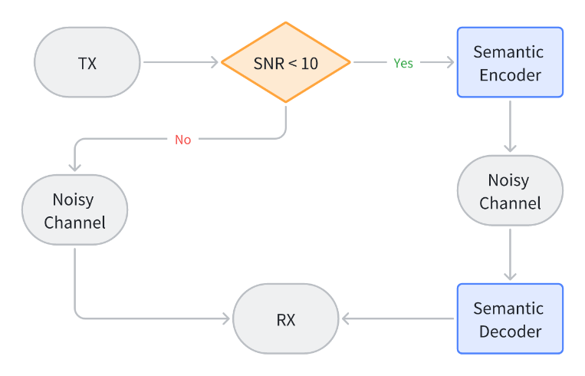The encoder applies different strategies based on SNR which is illustrated in Figure 1:

Figure 1: System Structure

a) Low-SNR Regime (SNR < 10 dB):

In this case, the channel is highly noisy, and directly transmitting raw images would result in significant degradation. Therefore, we employ a deep neural encoder-decoder pipeline that performs both compression and denoising. The encoder reduces the input dimensionality to a compact latent representation, which is more robust to noise, and the decoder reconstructs the image with enhanced perceptual quality. This neural processing helps preserve semantic meaning (e.g., class label) even when fine-grained pixel details are lost.

b) High-SNR Regime (SNR ≥ 10 dB):

When the channel is relatively clean, transmitting the raw image directly—without neural compression—is more efficient. In this regime, applying neural processing adds computational overhead without significant gains in semantic fidelity or image quality. Instead, we inject channel noise directly into the image and bypass the encoder-decoder network.

*2) Strategy advantages*

This adaptive strategy offers several advantages. First, it optimizes computational resources by only invoking the neural network, when necessary, which is particularly important for energy-constrained devices. Second, it maintains semantic robustness across a wide range of channel conditions, ensuring that classification or downstream tasks can still be performed reliably even in degraded environments. Lastly, the strategy demonstrates the flexibility of semantic communication systems in adapting to environmental dynamics, paving the way for more intelligent and context-aware communication protocols.

*C. Classifier*

A pre-trained 4-layer MLP classifier is used to evaluate semantic consistency. This network remains fixed and is used only to evaluate classification accuracy on decoded outputs.

For the CIFAR-10 dataset, we adopt a pre-trained GoogLeNet model to evaluate semantic consistency. GoogLeNet is a deep convolutional neural network architecture known for its inception modules, which allow it to extract multi-scale features efficiently with a relatively low parameter count. By comparing the classification accuracy of decoded outputs against ground truth labels, we assess how well semantic information is preserved under different SNR conditions and compression strategies.

IV. Experimental Setup

*A. Dataset*

We use the **MNIST** dataset of handwritten digits, which contains 60,000 training and 10,000 test samples.

In addition to MNIST, we incorporate the **CIFAR-10** dataset to test our adaptive semantic communication framework on more complex, high-dimensional images. We preprocess the CIFAR-10 images by normalizing the pixel values and resizing them if needed to match the input requirements of our convolutional encoder-decoder architecture and the GoogLeNet classifier.

*B. SNR Settings*

To evaluate the robustness and adaptability of the proposed semantic communication system, we simulate a wide range of channel conditions by selecting ten random **Signal-to-Noise Ratio (SNR)** values uniformly distributed between 0 and 20 dB. This range reflects both harsh low-SNR environments, where noise dominates the signal, and high-SNR settings, where channel distortion is minimal. These values are representative of typical wireless communication scenarios and enable a comprehensive assessment of the encoder-decoder system's performance under varying noise conditions.

This SNR-based evaluation also helps justify the dynamic switching behavior in our system, which adjusts encoding strategy based on the current channel condition, balancing between performance and computational cost.

*C. Compression Rates*

To evaluate the effectiveness of the semantic communication framework under different bandwidth constraints, we experiment with a range of **compression rates** from **0.1 to 1.0**, where the compression rate is defined as the ratio of the size of the latent representation to the original input size.

The encoder network is trained to map the input images into a compact latent space based on the desired compression rate, and the decoder attempts to reconstruct meaningful outputs from this compressed and noise-corrupted representation. Lower compression rates are more susceptible to noise and semantic distortion but are critical in bandwidth-constrained settings such as IoT or edge devices.

*D. Evaluation Metrics*

To assess the performance of our SNR-based adaptive semantic communication system, we employ two complementary evaluation metrics that capture both semantic and perceptual aspects of the reconstructed data:

*1) Accuracy*

Classification accuracy is used as the primary **semantic metric**, reflecting how well the meaning or class label of the transmitted image is preserved after compression and channel transmission. For MNIST, a pre-trained 4-layer MLP classifier is used to evaluate the decoded images; for CIFAR-10, we utilize a pre-trained GoogLeNet classifier. These classifiers remain fixed during all evaluations and are not involved in the transmission process itself. A high accuracy score indicates that the essential semantic content of the original image is retained despite channel noise and compression.

*2) Peak Signal-to-Noise Ratio (PSNR)*

PSNR (2) quantifies the **perceptual quality** of the reconstructed images by measuring the difference between the original and decoded image pixels. It is calculated in decibels (dB), with higher PSNR values indicating better visual fidelity and lower distortion. While semantic communication systems tolerate some degree of distortion in pixel space, maintaining reasonable PSNR ensures that reconstructions are not only semantically accurate but also visually meaningful to human observers.

(2)

MAXI: The maximum possible value of the signal (for 8-bit images, this is 255; for normalized images in [0,1], this is 1).

Together, **accuracy** and **PSNR** provide a balanced evaluation of the system’s ability to preserve both the **meaning** and **visual quality** of transmitted data. By analyzing these metrics across different SNR levels and compression rates, we demonstrate how our adaptive strategy maintains robust communication under varying conditions. In particular, we observe that neural encoding significantly improves classification accuracy in low-SNR regimes, while PSNR remains competitive with traditional transmission methods at higher SNR values.

V. Results and Analysis

*A. Effect of SNR and Compression Rate*

Table 1 and table 2 summarize the classification accuracy achieved by our adaptive semantic communication system under two representative SNR levels: **4.46 dB** and **8.44 dB**, with compression rates set to **0.1** and **0.4**, respectively. These conditions were selected to highlight the model's performance in low- and mid-SNR regimes, which are particularly relevant for real-world wireless communication scenarios.

Table 1: Accuracy over Epochs (SNR = 4.46dB)

|  |  |  |
| --- | --- | --- |
| Epoch | CR=0.1 | CR=0.4 |
| 1 | 0.645 | 0.754 |
| 5 | 0.936 | 0.962 |
| 10 | 0.949 | 0.973 |
| 15 | 0.951 | 0.976 |
| 20 | 0.955 | 0.978 |
| 30 | 0.949 | 0.977 |

Table 1: Accuracy over Epochs (SNR = 8.44dB)

|  |  |  |
| --- | --- | --- |
| Epoch | CR=0.1 | CR=0.4 |
| 1 | 0.685 | 0.769 |
| 5 | 0.953 | 0.968 |
| 10 | 0.971 | 0.978 |
| 15 | 0.973 | 0.98 |
| 20 | 0.975 | 0.981 |
| 30 | 0.974 | 0.981 |

*B. Discussion*

Our experimental results across both MNIST and CIFAR-10 datasets demonstrate the effectiveness of the proposed SNR-based adaptive semantic communication framework. Several key observations can be drawn:

*1) Adaptive Encoding Significantly Improves Low-SNR Performance:*

At an SNR of **4.46 dB**, the channel is severely degraded, making raw transmission of images ineffective due to substantial corruption. In this regime, the adaptive system engages the neural encoder-decoder pipeline to compress and denoise the input prior to transmission. This semantic-aware processing leads to a **substantial increase in classification accuracy**. For instance, in the MNIST case (Figure 2), we observe the accuracy rate still maintains high even under high compression ratios. Similar trends are evident for CIFAR-10 (Figure 3), where semantic preservation through neural encoding mitigates the impact of channel noise and improves the reliability of downstream inference.



Figure 2: MNIST Reconstructed Picture (Compression = 0.1)

 

Figure 3: CIFAR-10 Reconstructed Picture (Compression = 0.7)

*2) Higher Compression Rates Still Preserve Semantic Meaning:*

One of the main goals of semantic communication is to transmit "meaning" rather than raw data. Our experiments validate this principle: even at a **compression rate of 0.1** (as shown in Figure 4), where 90% of the input information is discarded, the system is able to reconstruct semantically valid representations. For MNIST, this corresponds to achieving **over 94% classification accuracy** at low SNRs. In CIFAR-10, while the dataset is more complex, semantic reconstruction under 0.7 compression still yields usable class information. This efficiency makes the system well-suited to bandwidth-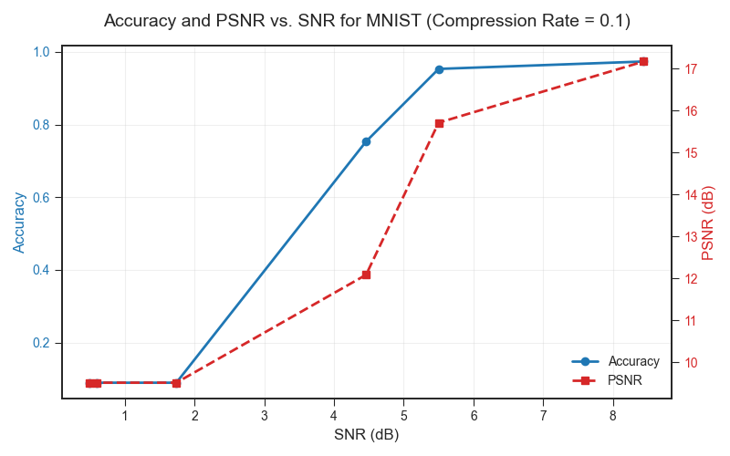constrained applications such as IoT and wireless edge devices.

Figure 4: Accuracy and PSNR (Compression = 0.1)

*2) At High SNRs, Direct Transmission Is Computationally Efficient with Negligible Performance Loss:*

When the channel is clean (e.g., **SNR ≥ 10 dB**), the adaptive system bypasses the neural encoder and sends the raw image with additive Gaussian noise. This strategy offers **computational savings** by avoiding the encoder-decoder pipeline when it is not needed. Our results confirm that at higher SNR levels, the performance difference between neural and direct transmission becomes minimal, particularly in terms of classification accuracy and PSNR. This dynamic adaptation ensures **efficient utilization of computation and energy**, enabling real-time operation in practical deployments.

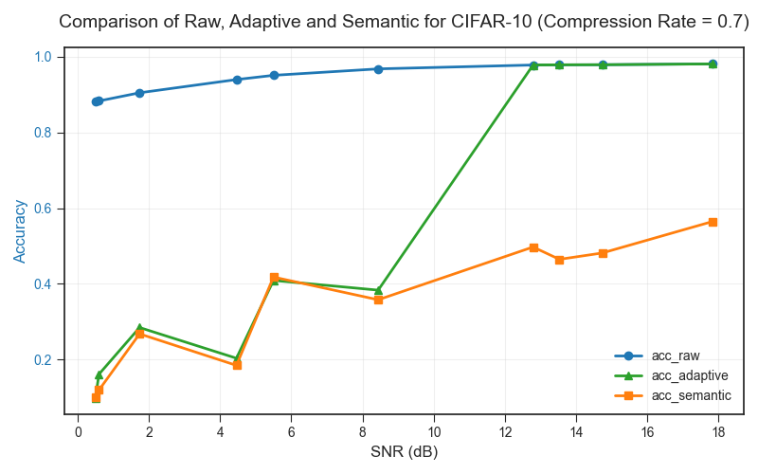The comparison of adaptive system to others is depicted in Figure 5.

Figure 4: Accuracy and PSNR (Compression = 0.1)

In summary, the adaptive semantic communication strategy enables the system to **respond intelligently to channel conditions**, improving both semantic fidelity and system efficiency. This represents a promising direction for the design of future communication systems that integrate machine learning with signal processing.

VI. Conclusion

In this work, we proposed an **SNR-based adaptive semantic communication system** that dynamically selects between neural encoding and direct transmission depending on the channel condition. This design enables the system to intelligently balance **semantic fidelity**, **reconstruction quality**, and **computational efficiency**.

Through comprehensive experiments on the MNIST dataset, we demonstrated that in low-SNR regimes (e.g., SNR ≈ 4.46 dB), deep neural encoding significantly improves both classification accuracy and perceptual quality, as measured by PSNR. Conversely, in high-SNR scenarios (e.g., SNR ≥ 10 dB), the system conserves computation by directly transmitting images, maintaining comparable accuracy while bypassing the encoder-decoder pipeline.

To evaluate generalizability, we extended our method to the more complex CIFAR-10 dataset, which contains 32×32 color images across diverse object categories. Even under aggressive compression (e.g., rate 0.7) and noisy channels, the adaptive semantic framework preserved key class information and delivered robust classification performance using a pre-trained GoogLeNet classifier. These results affirm the system's adaptability across both simple (MNIST) and complex (CIFAR-10) visual domains.

Overall, our findings suggest that adaptive semantic communication is a promising paradigm for future intelligent communication systems, particularly in scenarios involving bandwidth limitations, energy constraints, or dynamic wireless environments. Future work may extend this approach to video data, multimodal inputs, or reinforcement learning-based adaptation policies.

References

1. H. Zhang, S. Shao, M. Tao, X. Bi and K. B. Letaief, "Deep Learning-Enabled Semantic Communication Systems with Task-Unaware Transmitter and Dynamic Data," in *IEEE Journal on Selected Areas in Communications*, vol. 41, no. 1, pp. 170-185, Jan. 2023.
2. C. Chaccour, W. Saad, M. Debbah, Z. Han and H. Vincent Poor, "Less Data, More Knowledge: Building Next-Generation Semantic Communication Networks," in *IEEE Communications Surveys & Tutorials*, vol. 27, no. 1, pp. 37-76, Feb. 2025.
3. C. E. Shannon and W. Weaver, “The mathematical theory of communication,” University of Illinois Press, 1949.
4. J. Wu *et al*., "Semantic Communication for Efficient Image Transmission Tasks based on Masked Autoencoders," *2023 IEEE 98th Vehicular Technology Conference (VTC2023-Fall)*, Hong Kong, Hong Kong, 2023.
5. S. Wang, X. Zhang, and Y. Chen, “Adaptive semantic communication with task-oriented importance estimation,” in IEEE International Conference on Communications (ICC), IEEE, 2022, pp. 1–6.
6. E. Bourtsoulatze, D. Kurka, and D. Gunduz, “Deep joint source-channel coding for wireless image transmission,” IEEE Transactions on Cognitive Communications and Networking, vol. 5, no. 3, pp. 567–579, 2019.